Aki Gao
Homework 1
CS 4414
Operating Systems
Fall, 2015

(1)
variable definitions:
t1 = a - b
t2 = c + d
t3 = e – f
t4 = g + h

t5 = t1 * t2
t6 = t3 / t4

t7 = t5 + t6

process flow graph:
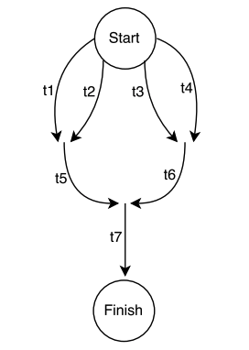

(2)
SEQ
PAR
SEQ
PAR
t1 := a – b
t2 := c + d

t5 := t1 * t2
SEQ
PAR
t3 := e – f
t4 := g + h

t6 := t3 / t4
t7 := t5 + t6

(3)
m = 2;
n = 2;
o = 2;

fork L2;

fork L4;
fork L5;

t1 = a – b; join m, L3; quit;
L2: t2 = c + d; join m, L3; quit;
L3: t5 = t1 * t2; join o, L7; quit;

L4: t3 = e -f; join n, L6; quit;
L5: t4 = g + h; join n, L6; quit;
L6: t6 = t3 / t4; join o, L7; quit;

L7: t7 = t5 + t6;

(3.12)
There will be 16 separate processes because the number of processes double in each iteration of the for loop in the program.

(3.13)
LINE J will never be reached because of the address space of the original child process will be overwritten with the /bin/ls binary file following the execlp system call before the printf function can be executed.

(3.14)
A: 0
B: 2603
C: 2603
D: 2600

(3.17)
X: CHILD: 0 CHILD: -1 CHILD: -4 CHILD: -9 CHILD: -16
Y: PARENT: 0 PARENT: 1 PARENT: 2 PARENT: 3 PARENT: 4

